

**2024 Boys’ Tennis Team Update / #6: 04/28/24**

**Here’s our look ahead for this coming week:**

1. **Our schedule for this coming week**. According to the schedule, we have a number of matches planned for this week. BUT, the weather may have something else in mind. We’ll see. Like I said in my last email, and the very first email, flexibility by all is the key to how we get thru this time of year and our season! On my part, I will try to communicate as much as needed to keep you up to date. On your part, please be patient with Jodi & I. Thank you.

Monday 4/29: JV Match vs. C-I @ home; V practice

Tuesday 4/30: V Match vs. Big Lake @ home; JV Match away vs. Princeton

Wednesday 5/1: Practice 3-5:30 at home

Thursday 5/2: Matches vs. Becker: V away, JV home

Friday 5/3: V Tri @ home at 1pm, with FL, Grand Rapids, St. Francis

Saturday 5/4: V Quad @ home, with Anoka, Brainerd, Centennial; JV Match @ Anoka HS

1. **Fundraiser.** The Adrenaline Fundraiser will come to a close on Wednesday the 1st. This time next week I will hopefully give you a total tally, and then have other comments about the money raised. At this time I want to thank all of the boys that participated in the AF, and I also want to thank those of you that chose to simply donate to the cause. Our goal for this fundraiser was to raise $6500. As of the writing of this email, I’m happy to announce that we are at approximately $6600 raised. Awesome job by all! And we’re not done yet.

IF you still want to contribute directly to the overall fund, you can write a check to: CLCA – Boys’ Tennis. Mail the check to the attention of:Craig Walker, 29400 Olinda Trail, Lindstrom, Mn. 55045

THANK YOU!

1. **Summer Training.** I mentioned this last email, and I’m going to mention it again. (In fact I’m going to continue to mention these summer classes) It’s not too early to mention the summer training classes that are going to be held. (In fact you may want to sign up asap because the number of participants is limited! Some of the classes are already filling up.) **I want all of the boys to be involved in the training.** This will extend their current training until the end of July when we as coaches are then restricted from working with them. It will also give me the opportunity to work with both the JV and V squads. The classes are held on Tuesday and Thursdays. More information can be found on the **HOME** page of our website ([www.chisagolakestennis.com](http://www.chisagolakestennis.com)) .

The class which I feel is best for our **JV practice squad** is class 7693-S24. The description is below:

THIS IS THE PREFERRED CLASS FOR ALL JUNIOR VARSITY PRACTICE GROUP PLAYERS:

CE CLASS# 7693-S24

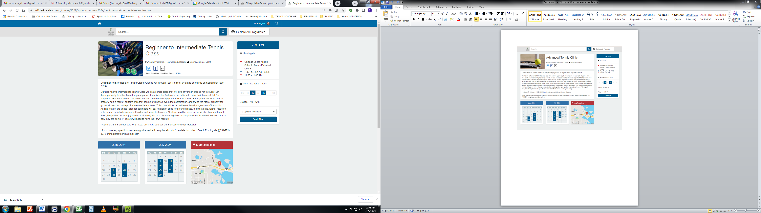

It is a beginner to intermediate class held on Tuesdays and Thursdays from 11AM until 11:45; from June 13th through July 30th.

Cost is ONLY $119 for the class.

The class I’d like to see all of the **Varsity practice squad** boys join is 7725-S24. The description is below:

THIS IS THE PREFERRED CLASS FOR ALL VARSITY PRACTICE GROUP PLAYERS:

CE CLASS# 7725-S24

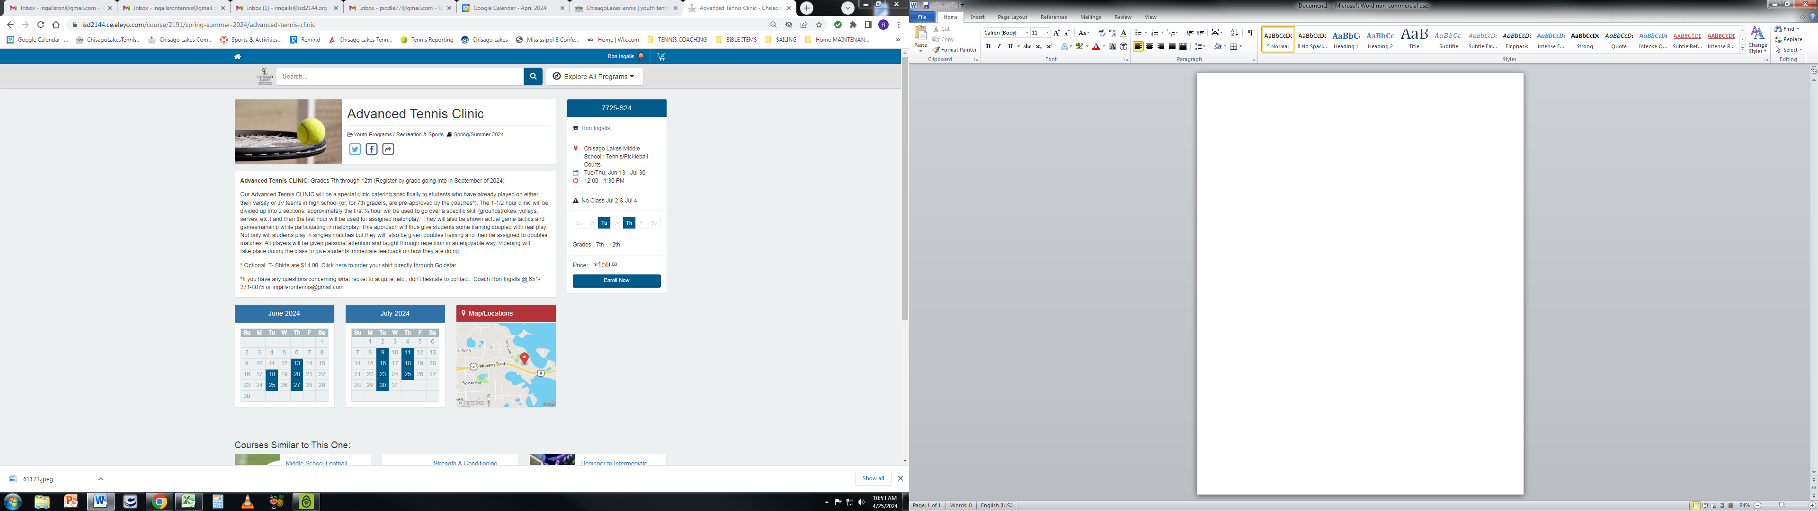

It is held on Tuesdays and Thursdays from NOON until 1:30PM; from June 13th through July 30th.

It is the preparation class for two tournaments being held throughout the summer: the first tournament is on June 27th and the second on July 25th.

Cost is ONLY $139 for the class.

1. **A video I want the V Practice Group boys to watch again!** I had the varsity practice group watch the following video on Friday before we went into the WCC and then practiced. I told them I wanted them to watch it again, and that I would send them the link. So here it is: <https://www.youtube.com/watch?v=hJ156pGktVM&t=2s>

If you are a JV practice group player, by all means feel free to watch the video also. It’s just that I am requiring the V practice group to watch it again before practice tomorrow!

If you have any further questions and/or comments, email me at: ingallsrontennis@gmail.com.

Thanks, Coach Ron