

**2024 Boys’ Tennis Team Update / #7: 05/05/24**

**Here’s our look ahead for this coming week:**

1. **Our schedule for this coming week**. According to the schedule, we have two matches planned for this week. BUT, the weather may ruin our plans once again. It’s an understatement to say that the weather has been incredibly bad for tennis this year! The schedule for now is as follows:

Monday 5/6: Practice 3-5:30 at home

Tuesday 5/7: Matches vs. C-I: V away, JV home

Wednesday 5/8: Practice 3-5:30 at home

Thursday 5/9: Matches vs. Hudson: V away, JV home

Friday 5/10: Practice 3-5:30 at home

1. **Fundraiser.** The Adrenaline Fundraiser has come to a close. Once again I want to thank all of the boys that participated in the AF, and I also want to thank those of you that chose to simply donate to the cause. As of the writing of this email, I’m happy to announce that we have raised close to an amazing $7000 for our cause.

Some of the monies will be spent on SWAG for the Varsity Practice Group and some will be spent on SWAG for the JV Practice Group. More details to come.

1. **Banquets.** There will be 2 separate banquets this year for the two practice groups. Coach Steve Otte will be heading up the year-end fun-day banquet for the JV Practice Group. He is tentatively planning on holding it on the 14th of this month in the afternoon/early evening.

Meanwhile, the V Practice Group year-end banquet will be held on the 30th after section play is completed.

More information is to follow on both of these, but please mark your calendars for now.

1. **Summer Training.** Once again I want to mention the summer training classes that are going to be held. **I really want all of the boys to be involved in the training.** This will extend their current training until the end of July when we as coaches are then restricted from working with them. It will also give me the opportunity to work with both the JV and V squads. The classes are held on Tuesday and Thursdays. More information can be found on the **HOME** page of our website ([www.chisagolakestennis.com](http://www.chisagolakestennis.com)) . You can also see more information on this below:

The class which I feel is best for our **JV practice squad** is class 7693-S24. The description is below:

THIS IS THE PREFERRED CLASS FOR ALL JUNIOR VARSITY PRACTICE GROUP PLAYERS:

CE CLASS# 7693-S24

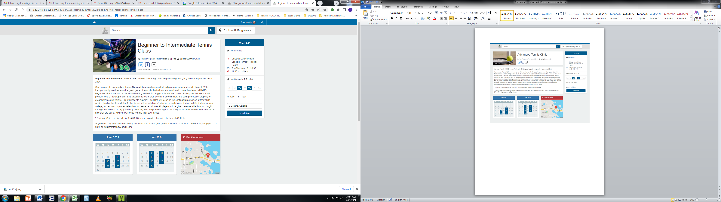

It is a beginner to intermediate class held on Tuesdays and Thursdays from 11AM until 11:45; from June 13th through July 30th.

Cost is ONLY $119 for the class.

The class I’d like to see all of the **Varsity practice squad** boys join is 7725-S24. The description is below:

THIS IS THE PREFERRED CLASS FOR ALL VARSITY PRACTICE GROUP PLAYERS:

CE CLASS# 7725-S24



It is held on Tuesdays and Thursdays from NOON until 1:30PM; from June 13th through July 30th.

It is the preparation class for two tournaments being held throughout the summer: the first tournament is on June 27th and the second on July 25th.

Cost is ONLY $139 for the class.

If you have any further questions and/or comments, email me at: [ingallsrontennis@gmail.com](mailto:ingallsrontennis@gmail.com).

Thanks, Coach Ron