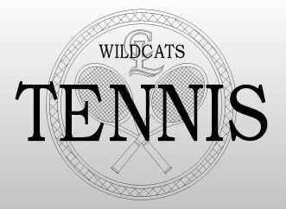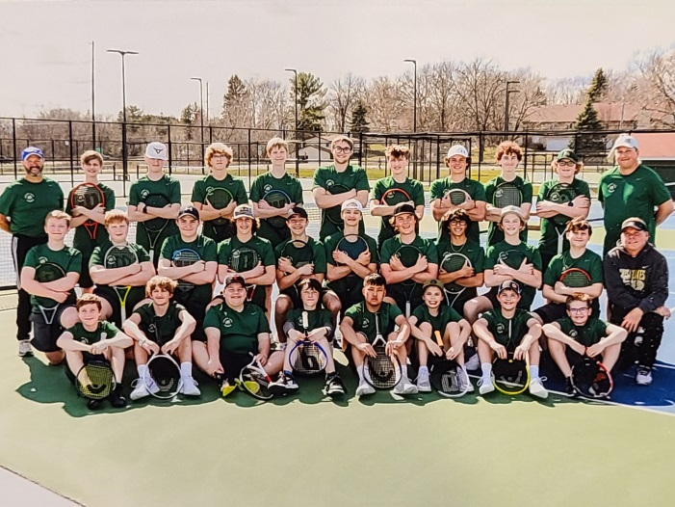

**2024 Boys’ Tennis Team Update / #8: 05/12/24**

**Good morning, Coach Ron here. I normally prefer to get these emails out to you on Sunday evening, but after a 2 hour zoom meeting for seeding last evening, I waited until this monring.**

1. **As usual, I’ll start out with the schedule for this coming week**. The schedule for now is as follows:

Monday 5/13: V Match @ home vs. N. Branch; JV Match away vs. Anoka

Tuesday 5/14: V Match away vs. Duluth East; JV Practice & Year-End Celebration at the courts

Wednesday 5/15: V Practice 3-5:30

Thursday 5/16: V TEAM Sections

Friday 5/17: V Practice 3-5:30

Saturday 5/18: V INDIVIDUAL Sections @ Elk River

1. **Fundraiser.**
2. Congratulations to our AF Fundraiser Raffle winners! Ashley Yang (giving funds for Nik Yang) was the winner of the $250 Amazon Gift Card; Arnold Sadowsky (giving funds for Connor Frederixon) was the winner of the $125 Amazon Gift Card; and Anna Kern (giving funds for the Kern boys) was the winner of the $75 Amazon Gift Card.
3. There has also been a last minute large donor for our cause. **Morrie’s Brooklyn Park Subaru has donated $1000 for our cause.** A huge thank you goes out to them! (By the way, my wife Tina is the New Car Sales Manager at that location so if you are ever looking for a new Subaru, please keep her in mind. You can reach her at: Tina Ingalls @ 651-260-8171.)
4. I reported last time that we had raised over $7K for our cause (that was before the latest $1K donation), and also that some of the monies will be spent on SWAG for the Varsity Practice Group and some will be spent on SWAG for the JV Practice Group. So here’s how some of that SWAG will be split up: all of the V Practice Group are receiving new tennis bags with eventual C/L Boys’ Tennis logos on the side from Goldstar, and all of the JV Practice Group will be credited $75 each toward an online store being set up for us by Goldstar (store opening date to follow later).
5. **Banquets.** There will be 2 separate banquets/celebrations this year for the two practice groups. (This is a new idea that may or may not be repeated next year.) Coach Steve Otte will be heading up the year-end fun-day banquet for the JV Practice Group. He is tentatively planning on holding it on the 14th of this month in the afternoon at practice. Meanwhile, the V Practice Group year-end banquet will be held on the 30th after section play is completed.
6. **Feedback from parents.** I sent an email out on the 7th to all of the parents of team members that are part of the JV Practice Group. I’ve heard back from a few of you at this time, but I would like to encourage the rest of you to respond. If you don’t respond, I’ll assume your sons are coming back next year and you are satisfied with how the program is going. I will be sending the same questionnaire out to V parents later.
7. **Section Seeds.** As I said before, the 2024 seeding meeting was held last evening. Results of that meeting can be found on our website about half way down on the Boys’ HS Team page. Good luck to the varsity team and all the boys participating in individual matches.
8. **Summer Training.** I don’t want to sound like a broken record here (wow – that dates me), but once again I want to mention the summer training classes that are going to be held. **I really want all of the boys to be involved in the training.** This will extend their current training until the end of July when we as coaches are then restricted from working with them. It will also give me the opportunity to work with both the JV and V squads. The classes are held on Tuesday and Thursdays. More information can be found on the **HOME** page of our website ([www.chisagolakestennis.com](http://www.chisagolakestennis.com)) . You can also see more information on this below.

**If you have any further questions and/or comments, email me at:** [**ingallsrontennis@gmail.com**](mailto:ingallsrontennis@gmail.com)**.**

**Thanks, Coach Ron**

The class which I feel is best for our **JV practice squad** is class 7693-S24. The description is below:

THIS IS THE PREFERRED CLASS FOR ALL JUNIOR VARSITY PRACTICE GROUP PLAYERS:

CE CLASS# 7693-S24

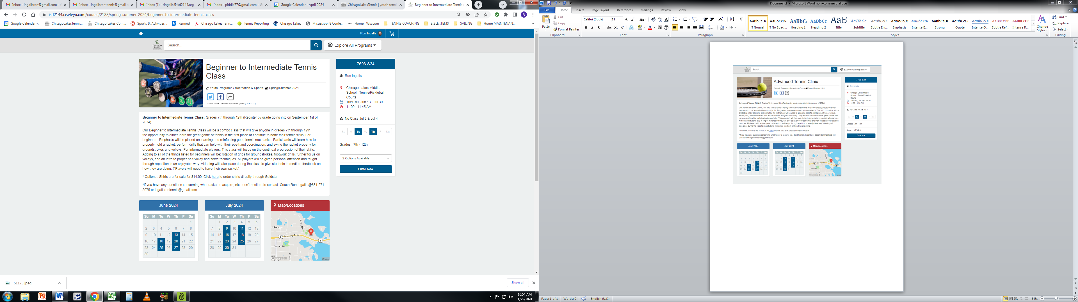

It is a beginner to intermediate class held on Tuesdays and Thursdays from 11AM until 11:45; from June 13th through July 30th.

Cost is ONLY $119 for the class.

The class I’d like to see all of the **Varsity practice squad** boys join is 7725-S24. The description is below:

THIS IS THE PREFERRED CLASS FOR ALL VARSITY PRACTICE GROUP PLAYERS:

CE CLASS# 7725-S24

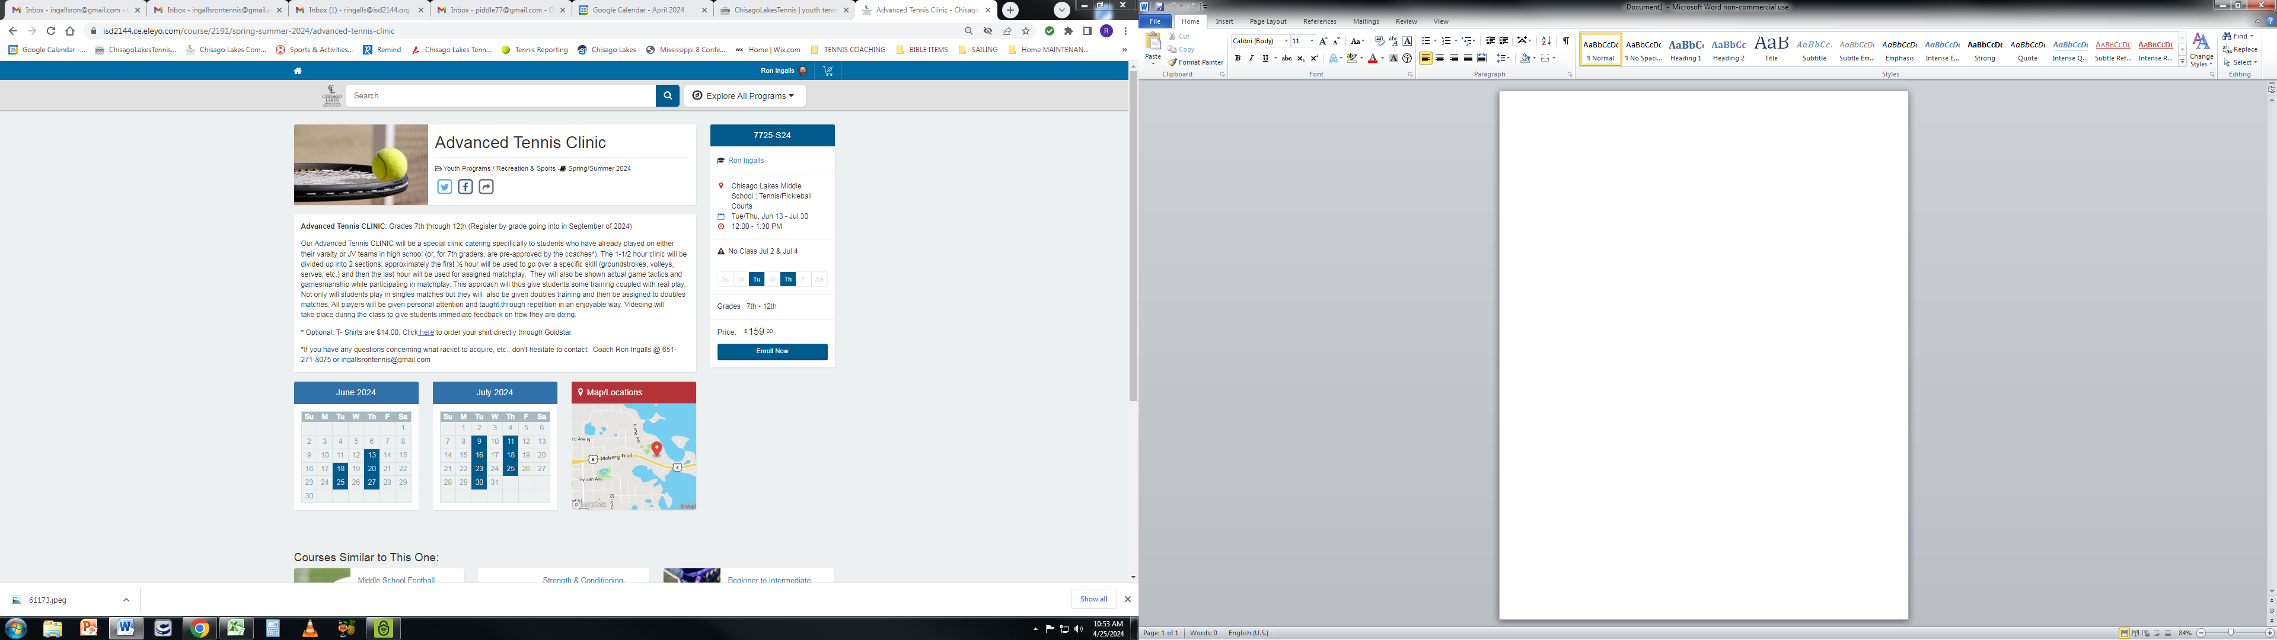

It is held on Tuesdays and Thursdays from NOON until 1:30PM; from June 13th through July 30th.

It is the preparation class for two tournaments being held throughout the summer: the first tournament is on June 27th and the second on July 25th.

Cost is ONLY $139 for the class.